
HY/ECAK/1119A 28/11/2019
HALF YEARLY EXAMINATION (2019-20)
Subject: ECONOMICS (ANSWER KEY)  Grade: XI |  | Max. Marks: 80  Time: 3 Hrs
 | SECTION A: STATISTICS
 | Ans: a |  | 1
 | Ans: A discrete variable increases in jumps, like no of students  A continuous variable increases in gradually and can be expressed in fractions. Eg height |  | 1
 | Ans: d |  | 1
 | Ans: cannot show many data; can show only approx. values; can be misused for propaganda, etc |  | 1
 | c)Mode |  | 1
 | Ans: d |  | 1
 | Ans: 28  OR  ZERO |  | 1
 | Ans:Z=3M -2 Mean = 18 |  | 1
 | Range = 20, Coeff = 0.4 |  | 1
 | Does not include entire series |  | 1
 | a)The number of times a variable occurs + Any relevant example ( ½ + ½ )  b. middle value of a class interval by dividing lower and upper limits by 2. + Any relevant example ( ½ + ½ )  c)Upper limit included in the class itself. + Any relevant example ( ½ + ½ )  OR  (1/2 mark for each value) |  | 3
   | 2005 |  |  | 2007
   | Male | Female | Total | Male | Female | Total
  TU | 1110 | 162 | 1272 | 1450 | 850 | 2300
  Non TU | 180 | 128 | 208 | 300 | 400 | 700
  Total | 1290 | 290 | 1580 | 1750 | 1250 | 3000
 | Ans: Modal class= 30-40. Mode = 35  ½ mark formula  Conversion (1 mark):  Answer -1.5 marks |  | 3
  Marks | 0-10 | 10-20 | 20-30 | 30-40 | 40-50 | 50-60 | 60-70
  No. of students | 2 | 5 | 8 | 10 | 8 | 5 | 2
 | a)In percentage bar diagram, value are converted into percentages and depicted into subdivided bars. In pie diagram, values are converted into degrees and then depicted on a pie. Can only depict one years data on a pie, whereas subdivided percent bar can depict data for multiple years (1 mark)  Conversion- 1 mark  Pie – 2 mark (deduct half mark if legend not given/ or marked on diag, or if degrees not marked on pie)  OR  i) Difference – in bar, only the frequency is considered, therefore one dimensional. In histogram, both class width and frequency considered, therefore two dimensional (1 mark)  ii)Adjustment factor (0.5 marks) Adjusted frequency (1 mark) Histogram (1.5 mark): |  | 4
   | Favorite Type of Movie
  Items | Comedy | Action | Murder mystery | Drama | SciFi
  No of friends | 4 | 5 | 6 | 1 | 4 | 20
  % share | 20% | 25% | 30% | 5% | 20%
  Share in terms of components of 360 | 72 | 90 | 108 | 18 | 72
  Marks | 10-20 | 20-30 | 30-50 | 50-60 | 60-80 | 80-100
  7Students | 5 | 15 | 20 | 13 | 12 | 10
  Adjustment Factor | 1 | 1 | 2 | 1 | 2 | 2
  Adjusted frequency | 5 | 15 | 10 | 13 | 6 | 5
 | Q1= size of 1.5th item = 140  Q3 = size of 4.5th item = 182  QD=161  ∑X= 1014; Mean= 169  MDx=157.166=157.2 |  | 4
   | dx
  120 | 49
  160 | 160
  176 | 176
  180 | 180
  184 | 184
  194 | 194
  ∑dx= | 943
 | Ans:  Q1= size of n/4 item = size of 10th item = 16.5  Q3 – size of 3N/4 item= size of 30th time = 27.5  QD=11/5=5.5  (Table - 1 mark, Q1- 1 mark, Q3 - 1 mark, QD -1 mark ) |  | 4
  CI | F | Cf
  9.5-14.5 | 6 | 6
  14.5-19.5 | 10 | 16
  19.5-24.5 | 5 | 21
  24.5-29.5 | 15 | 36
  29.5-34.5 | 3 | 39
  34.5-39.5 | 1 | 40
 | a) Merit- unaffected by extreme values (or any other merit). Demerit – not amenable to arithmetic treatment, not based on all observations (or any other demerit) ( ½ + ½ marks)  b)Median is 20  Median Formula + calculation + answer – 0.5+ 1+1 (2 marks)  More than ogive (1.5 marks)  Less than ogive (1.5 marks) |  | 6
 | Ans:  a)Spread  1 mark for median ( ½ mark Median formula + ½ mark answer), 1 mark for formula for MD, 2 mark for table, ½ mark for putting values in formula, ½ mark for ans;, 1 mark for Coeff of MD  OR |  | 6
  CI | Midvalue | f | cf | X-median | Fdx
  0-10 | 5 | 3 | 3 | 30 | 90
  10-20 | 15 | 8 | 11 | 20 | 160
  20-30 | 25 | 4 | 15 | 10 | 40
  30-40 | 35 | 10 | 25 | 0 | 0
  40-50 | 45 | 9 | 34 | 10 | 90
  50-60 | 55 | 6 | 40 | 20 | 120
   |  | 40 |  |  | 500
   | 20 |  | Median | 35
  MDm | 12.5
  Coeff of MDm = |  | 0.36
  X values | F | FX | X-Mean | Fdx
  5 | 2 | 10 | 15 | 30
  10 | 4 | 40 | 10 | 40
  15 | 6 | 90 | 5 | 30
  20 | 8 | 160 | 0 | 0
  25 | 6 | 150 | 5 | 30
  30 | 4 | 120 | 10 | 40
  35 | 2 | 70 | 15 | 30
   | 32 | 640 |  | 200
  Mean |  | 20
  MD from mean |  | 200/32 = | 6.25
  Coeff of mean dev - |  | 6.28/20= | 0.3125
 | SECTION B: MICRO ECONOMICS
 | Ans: a) |  | 1
 | Ans: No change in PPC . Economy moves from within the PPC to on the PPC. Diagram ( ½ + ½ mark) |  | 1
 | Ans: Macro is the study of economy as a whole, while micro is the study of individual units, or any other valid difference. |  | 1
 | Ans: True. Economics is the study of scarcity. It arises because resources are scarce, human wants are unlimited and resources have alternate uses  OR  Eg: Whether to produce war time goods (guns) or peace time goods(butter)  Or, whether to produce capital goods (machines) or consumer goods (wheat) (any one example) |  | 1
 | Ans: b |  | 1
 | Ans: No, because the nature of the goods is different. Salt is a necessity, and hence its qty demanded will not be affected. However, cigarettes are non-essential commodities, and hence consumer will decrease qty demanded when price increases |  | 1
 | Ans:d |  | 1
 | Ans: Explicit cost –interest on loan taken. Implict – rent of self-owned shop |  | 1
 | False, AC=AFC+AVC/. AFC falls continuously but never = 0 because TFC is never equal to zero |  | 1
 | Ans: b |  | 1
 | Ans  Formula – 1 mark  Change in price = (-)16; (1 mark)  New price = 40 +(-)16 = ₹24 (1 mark)  OR  Income effect, Substitution effect, Law of DMU ( 1 mark each) |  | 3
 | 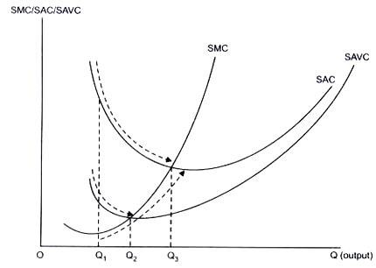  Ans:  a)False. When MC is rising, AVC is falling between Q1 and Q2. ( 1 mark diag, 0.5 mark diag)  b)False. When MR is constant, TR is increasing at a constant rate( 1 mark for reaoning, 0.5 for table) |  | 3
  Output | TR | MR
  1 | 10 | 10
  2 | 20 | 10
  3 | 30 | 10
 | Ans:  MOC – 1, 2, 3 4 (1mrk)  PPC – increasing MOC/ MRT implies convexity of the PPC. Increasing MOC implies that to get an additional unit of X, the economy has to sacrifice more and more of Y. This is because resources are not equally efficient (1.5mark)  PPC is downward sloping – because of scarcity of resources , so to get more of one good, the economy has to sacrifice the other good (1.5) |  | 4
 | Ans  Apple and windows computers are substitute goods (0.5)  When price of apple comp falls, demand for windows based computers will fall. (0.5) Demand curve will shift to the left + Diag (1 mark)  OR  In this case, 2/1>2/2 or MU(tea)/P(t) > MU(c)/ P(c) (1 mark) so he is not in eqm – 1 mark  Thus, he increases consumption of tea (leading to fall in MUt) and decreases that of coffee(leading to rise in MUc) till equilibrium is restored (1 mark |  | 4
 | Ans:  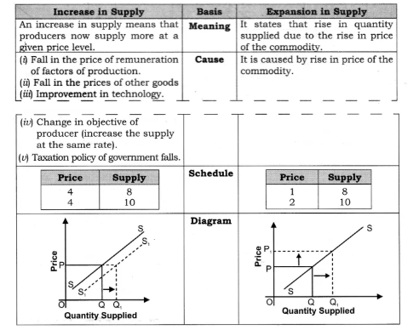  OR |  | 4
  Output | Total Cost | Average Variable Cost | Marginal Cost
  0 | 30
  1 | 30 | 20 | 20
  2 | 68 | 19 | 18
  3 | 84 | 18 | 16
  4 | 102 | 18 | 18
  5 | 125 | 19 | 23
 | 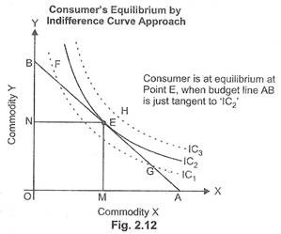  Ans:  Definition of consumer equilibrium – 1 mark  Conditions – MRS=Px/Py and Law of DMRS holds (1 mark)  IC₁, IC₂ and IC₃ are the three indifference curves and AB is the budget line. With the constraint of budget line, the highest indifference curve, which a consumer can reach, is IC₂. The budget line is tangent to indifference curve IC₂ at point ‘E’. This is the point of consumer equilibrium, where the consumer purchases OM quantity of commodity ‘X’ and ON quantity of commodity ‘Y. ( 1 mark)  Diag 1 mark  Disequilibrium – 2 cases MRS>Px/Py & MRS< Px/Py – 2 marks  ;  - |  | 6
 | Schedule: 1 mark ( ½ mark MC, ½ mark MR)  Identification of profit max output = 5 units – (1 mark)  Defn of producers – 1 mark;  Eqm condition – 1 mark;  Explanation – 2 marks  OR  The law of variable proportion states that if we go on using more and more units of a variable factor with fixed factor TPP increases at an increasing rate in the beginning then increases at a diminishing rate after a level of output and ultimately it falls. In accordance with the law MPP increases in the beginning, then it starts falling but remains positive and it continues to fall and becomes negative. The following diagram illustrates the law:-  Phase I : TP Increases at increasing rate : In the initial phase as more and more units of variable factor are employed with fixed factor total physical production increases at increasing rate, MP increases. This is from pt O to pt M or 0-3 units of Labour. Reasons: underutilization of fixed factor, indivisibility of factors  Phase II (pt M-N or 4to 6 units of L): TP increases at decreasing rate : As more and more units of variable factors are employed with fixed factors then total product increases at diminishing rate, MP decreases but is positive. At the end of this phase TP maximum and MP becomes zero. Reasons: optimal utilization of fixed factor; lack of perfect substitutes  Phase III (pt L onwards or 7th unit o L onwards): TP falls : As more and more units of variable factors are employed with given fixed factors, total production starts decreasing and marginal product becomes negative. Reasons overutilization of fixed factor (1 for defn+ 1 for diag, explanation 3 marks (– ½ mark for explanation ½ for reasoning for each stage; ½ mark cut if the student does not name the phase)  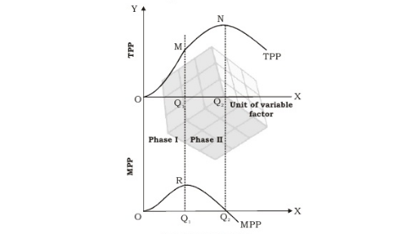  Rational producer produces in phase 2 + reasoning (no marks without reasoning) – 1 mk |  | 6
  Output (units) | TC | MC
  1 | 8 | 8
  2 | 14 | 6 | MC=MR but not eqm
  3 | 18 | 4
  4 | 23 | 5
  5 | 29 | 6 | Eqm level of output
  6 | 36 | 7
***

